**ARTIFICIAL INTELLIGENCE AND MACHINE LEARNING**

**A PROJECT REPORT**

***Submitted by***

**Sarthak Sachdev** (19BAI10004)

**Harsh Bajpai** (19BAI10062)

**Rohit NS** (20BAI10030)

*in partial fulfilment for the award of the degree*

*of*

**BACHELOR OF TECHNOLOGY**

*in*

**PROGRAM OF STUDY**

**Computer Science and Engineering**



**Project Title:**

**Smart Mathematics Tutor**

JUNE 2022

**ACKNOWLEDGEMENT**

First and foremost, I would like to thank the Lord Almighty for His presence and immense blessings throughout the project work.

I wish to express our heartfelt gratitude to **SmartBridge**, EdTech organization for much of his valuable support encouragement in carrying out this work.

I would like to thank our internal guide **Shivam Shivhare,** for continually guiding and actively participating in my project, giving valuable suggestions to complete the project work.

I would like to thank all the technical and teaching staff of the School of Computer Science and Engineering, who extended directly or indirectly all support.

Last, but not the least, I am deeply indebted to my parents who have been the greatest support while I worked day and night for the project to make it a success.

**TABLE OF CONTENTS**

|  |  |  |
| --- | --- | --- |
| **CHAPTER NO.** | **TITLE** | **PAGE NO.** |
| 1 | **INTRODUCTION** |  |
| 2 | **LITERATURE SURVEY** |  |
| 3 | **THEORETICAL ANALYSIS** |  |
| 4 | **EXPERIMANTAL ANALYSIS** |  |
| 5 | **FLOWCHART** |  |
| 6 | **RESULT** |  |
| 7 | **ADVANTAGES AND DISADVANTAGES** |  |
| 8 | **APPLICATION** |  |
| 9 | **CONCLUSION** |  |
| 10 | **FUTURE SCOPE** |  |
| 11 | **BIBLIOGRAPHY** |  |
| 12 | **APPENDIX** |  |

* **INDRODUCTION**
* **Introduction**

Our project ‘Smart mathematics Tutor’ includes shape recognition system. The aim of our project is to create tutoring assistant which will prove to be effective in helping Math students to practice shape recognition exercises. For the assistant to provide the needed guidance to a student who are learning to recognise the shapes, it is necessary to take into consideration both the shape that is needed to be recognised, as well as the name of the shape proposed by the learner.

This tutoring assistant will use a shape generator designed to test the knowledge of the student. This shape generator is created by our team to form different shape so that the students can try guess the name of the shapes and find if their answer was correct or not which will help them build their knowledge in an easy way. Shape detection is the identification of a shape in the image along with its localisation and classification. It has wide spread applications and is a critical component for AI based software systems. And by using this shape detection our tutor will help students learn about different shapes.

* **Overview**

Our website being a computer based online system, it can be proved to be efficient and easy in creating different shapes and recognizing them which will be helpful for students who are learning about shapes.

**1.3 Purpose**

Can we develop a website that efficiently manage shape details, increase accuracy and make it overall user friendly? And while doing so the website should be secure and simple to understand.

* **LITERATURE SURVEY**

**Existing Problem**

Shape detection is the identification of an shape in the image along with its localisation and classification. It has wide spread applications and is a critical component for AI based software systems. This report seeks to perform a rigorous survey of modern shape detection algorithms that use Machine learning. As part of the survey, the topics explored include various algorithms, quality metrics, speed/size trade-offs and training methodologies. This report focuses on the two types of Shape detection algorithms - CNN and Data Pre-processing. Techniques to construct detectors that are portable and fast on low powered devices are also addressed by exploring new lightweight convolutional base architectures. Ultimately, a rigorous review of the strengths and weaknesses of each detector leads us to the present state of the art.

**Problem Solution**

“Shape Matching and Object Recognition Using Shape Contexts”, proposed shape detection method using a feature called shape context. Shape context describes all boundary points of a shape with respect to any single boundary point. Shape recognition can be achieved by matching this feature with a prior knowledge of the shape context of the boundary points of the object.

* **THEORETICAL ANALYSIS**

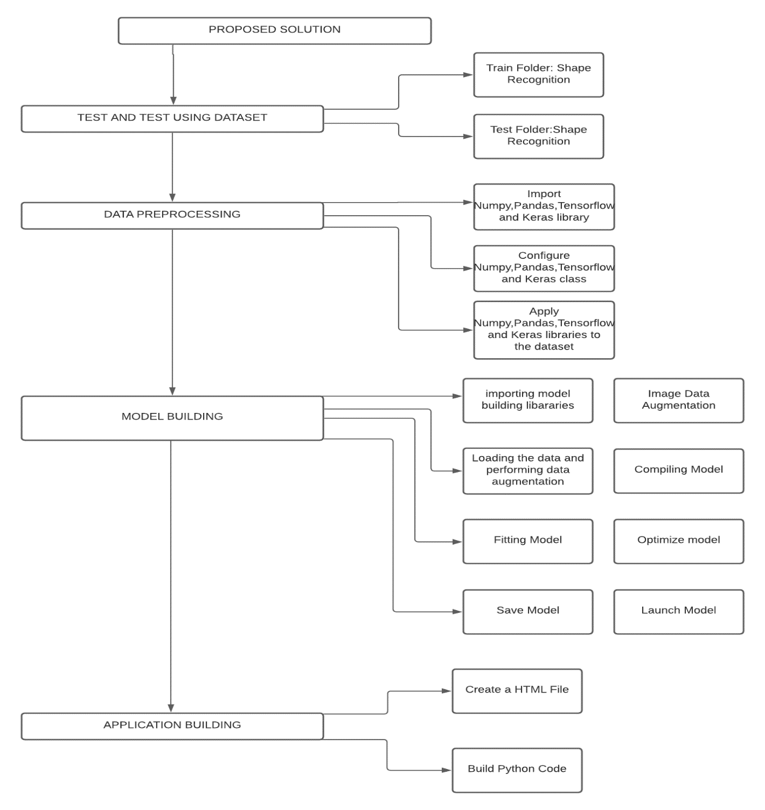

**Hardware /Software designing**

**Hardware requirement:** Laptop

**Software requirement:** Python – 3.6, Keras – 2.2.4, TensorFlow – 1.13.0, Spyder, Juypter Notebook

* **EXPERIMENTAL INVESTIGATIONS**

 We investigate shape recognition that models the decision based on supervised learning, where the model is built up based on previously labelled inputs denoted as templates; the set of already known inputs is denoted as training and testing set.

Independently from the exact type and behaviour of the classifier, the classification is a comparison of the input to labelled elements from the training set (or a model built up from the set), where the decision is a function of the representation.

The difference between the representations of the same object is a result of various distortions that occur during the shape acquisition and Data pre-processing.

The task of the recognition is not the reconstruction of the original shape by mathematical operations but to classify independently from transformations that distort the original and the template shapes and thus to estimate the ground truth.

The major challenges of shape detection are to ignore the differences in the representation resulting by sensing and preprocessing and to recognize if the difference is caused by different input objects.

**FLOWCHART**

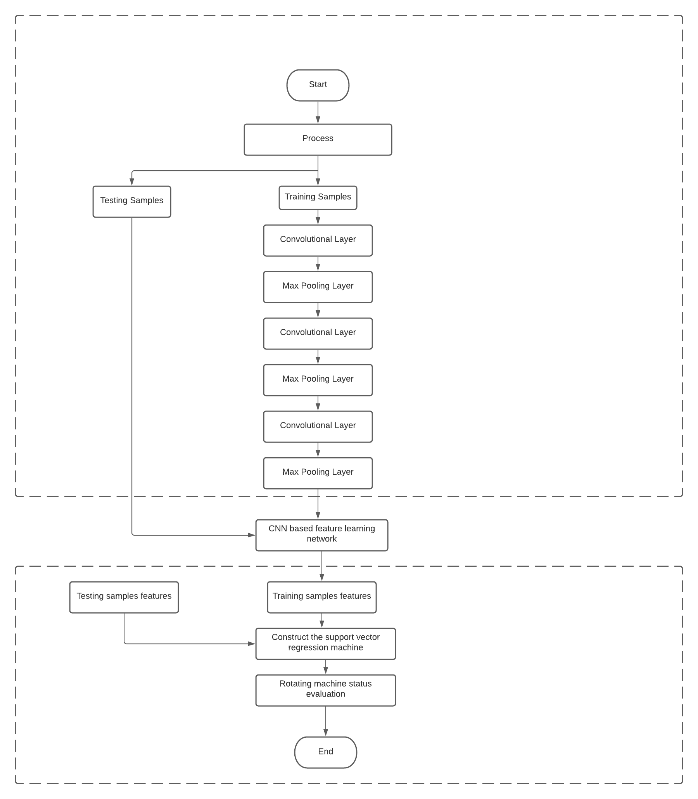

**6. RESULTS**

Smart Mathematics Tutor developed by us is an achievement that could change the education and learning experience of a student. It keeps it easy for the students to learn and for the teachers to perform their duties in a better way.

The Modules of Smart Mathematics Tutor developed by our team shows their own efficiency and effectiveness. With the help of this system, it will be easy to manage and upgrade the tutor system according to the demand and requirements.

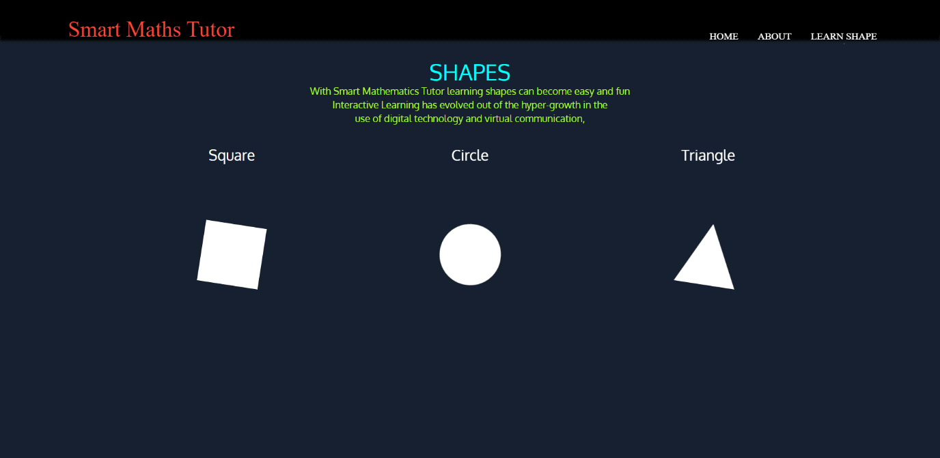

Fig 1. Home page

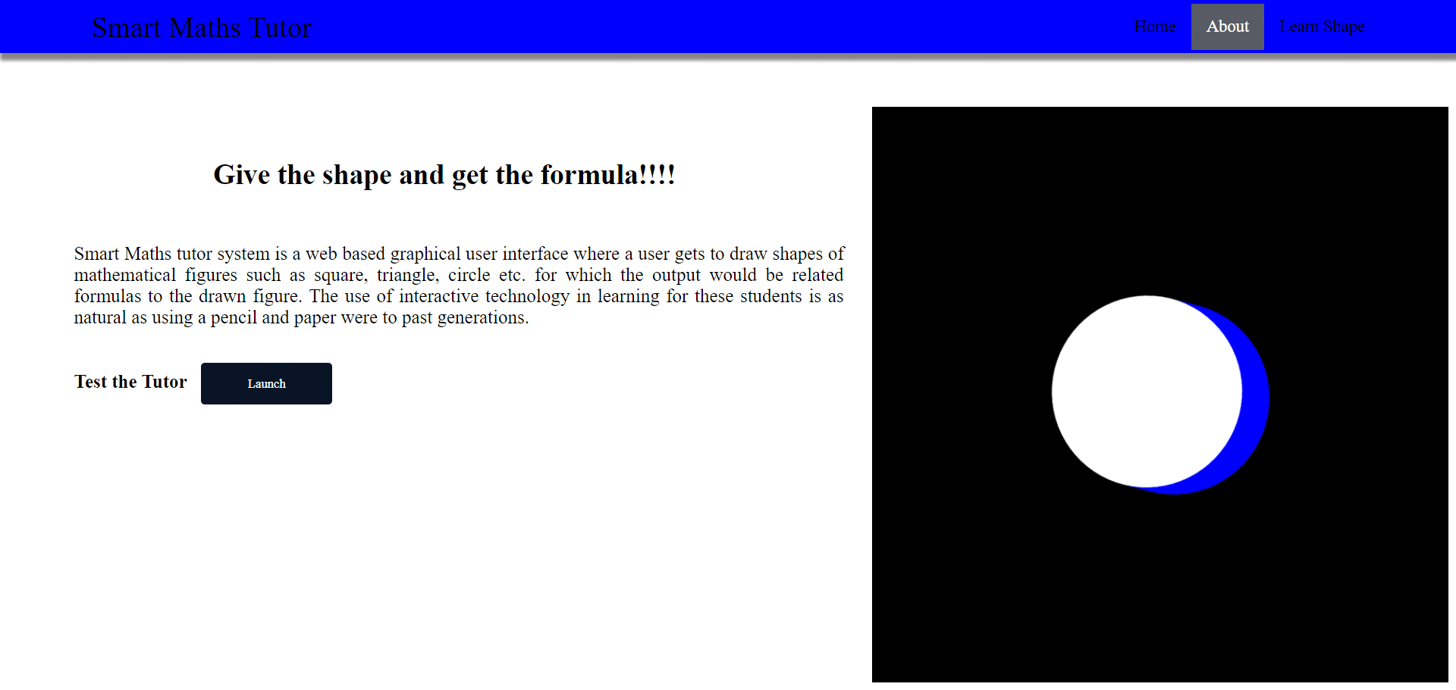

Fig 2. About Us page

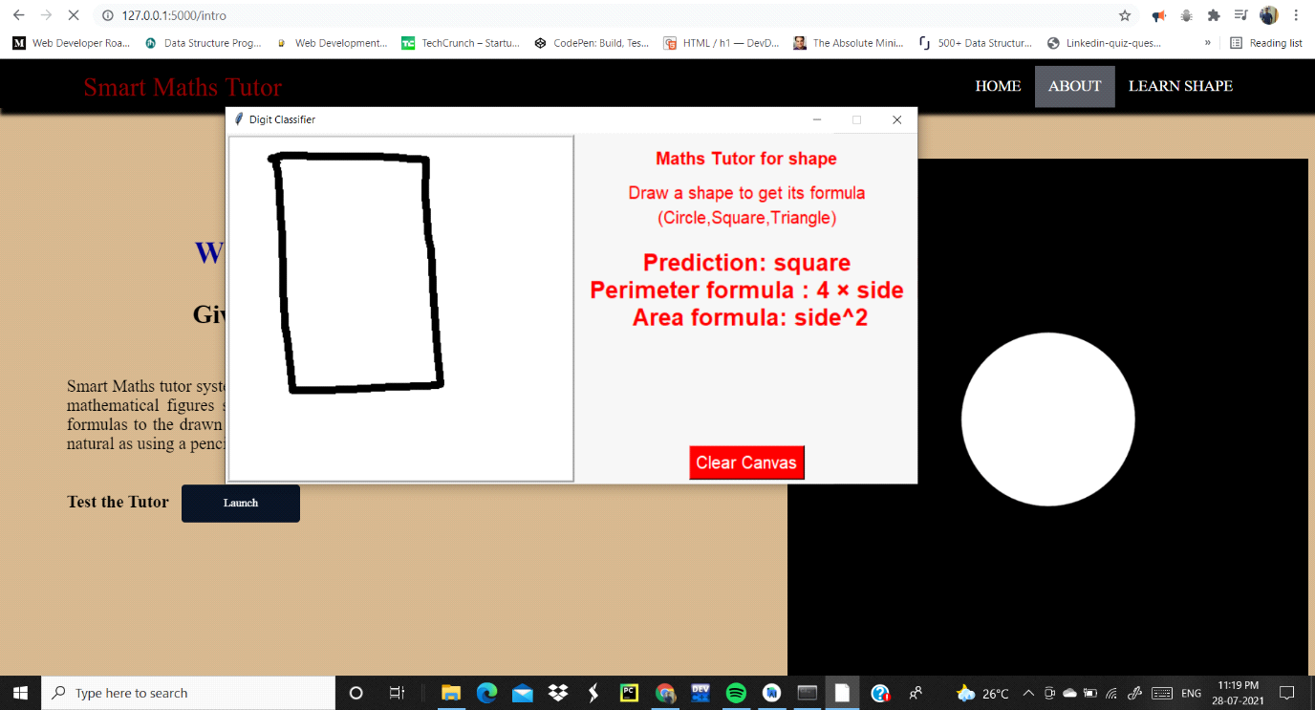

Fig. 3 Learn Shape Page

**7. ADVANTAGES AND DISADVANTAGES**

**Advantages** of Smart Mathematics tutoring systems are:

1. Be available at any time of the day, even late at night before an exam.

2. Provide [real-time data to instructors](https://www.opencolleges.edu.au/informed/learning-analytics-infographic/) and developers looking to refine teaching methods.

3. Reduce the dependence on human resources

4. Help students better understand material by allowing them to first explain what they know, then by catering responses accordingly

5. Afford educators the opportunity to [create individualized programs](https://www.opencolleges.edu.au/informed/features/customized-instruction-four-characteristics-of-effective-instructional-explanations/) due to their personalized nature.

6. Yield higher test scores than traditional systems, especially in students from special education, non-native English, and low-income backgrounds.

7. Provide immediate yes/no feedback, individual task selection, on-demand hints, and support for mastery learning.

**Disadvantages** ofSmart Mathematics tutoring systems are:

1. It is difficult to assess the effectiveness of SMT programs.

2. Immediate feedback and hint sequences fail to develop deep learning in students.

3. Systems fail to ask questions of students which might explain their actions.

4. The implementation of SMTs may be difficult to justify to an administrative staff.

5. Evaluation of an intelligent tutoring system is often difficult, costly, and time consuming.

6. Human tutors are currently better able to provide appropriate dialogue and feedback.

7. Human tutors are currently better able to interpret and adapt to different emotional states.

**8. APPLICATION**

Shape detection is breaking into a wide scope of enterprises, with use cases extending from individual security to efficiency in the working environment. Shape detection is applied in numerous territories of image processing, including picture retrieval, security, observation, computerized vehicle systems and machine investigation. Critical difficulties remain in the field of object detection. The potential outcomes are inestimable with regards to future use cases for object detection.

**Tracking objects**

A Shape detection framework is additionally utilized in tracking the shapes/objects, for instance tracking a ball during a match in the football world cup, tracking the swing of a cricket bat, tracking an individual in a video.

Object tracking has an assortment of uses, some of which are surveillance and security, traffic checking, video correspondence, robot vision and activity.

**People Counting**

Shape detection can be additionally utilized for People counting. It is utilized for dissecting store execution or group measurements during festivals. These will, in general, be progressively troublesome as individuals move out of the frame rapidly (likewise in light of the fact that individuals are non-inflexible objects).

**Automated CCTV surveillance**

Surveillance is a necessary piece of security and watch. Ongoing advances in computer vision innovation need to prompt the improvement of different programmed surveillance systems. Be that as it may, their viability is influenced by numerous factors and they are not totally dependable. This examination researched the capability of an automated surveillance system to diminish the CCTV administrator outstanding task at hand in both discovery and following exercises.

**Person Detection**

Person detection is necessary and critical work in any intelligent video surveillance framework, as it gives the essential data to semantic comprehension of the video recordings. It has a conspicuous augmentation to automotive applications because of the potential for improving security frameworks. Person detection is undertakings of Computer vision frameworks for finding and following individuals. Person detection is the task of finding all examples of individuals present in a picture, and it has been most broadly achieved via looking through all areas in the picture, at all potential scales, and contrasting a little region at every area with known layouts or examples of individuals. Person detection is commonly viewed as the initial procedure in a video surveillance pipeline and can take care of into more significant level thinking modules, for example, action recognition and dynamic scene analysis.

**Vehicle Detection**

Vehicle Detection is one of the most important part in our daily life. As the world is moving faster and the numbers of cars are kept on increasing day by day, Vehicle detection is very important. By using Vehicle Detection technique, we can detect the number plate of a speeding car or accident affected car. This also enables for security of the society and decreasing the number of crimes done by car. By using Vehicle Detection Technology Pixel Solutionz have successfully detected the speed of the vehicle and we have also detected the number plate of the car using Optical Character Recognition (OCR). By detecting the Number plate, Pixel Solutionz managed to measure the speed of the vehicle and for and oil company we have successfully developed a Safety Alert System with collision detection warning alert.

**9. CONCLUSION**

We presented a new shape description and classification method. Key characteristics of our approach are the compound descriptor and classifier that join the region and contour-based features. We suggested an online learning method to extend the representative set and increase performance. We proposed a representative set optimizing algorithm as well.

The core idea behind our method is the two-level description and classification: for an input shape, low-level, global statistical information is extracted to roughly select the set of similar objects and to reject obviously different templates. In the second stage, local edge information is investigated to find the closest known shape but with the ability to reject the match. The refusal is based on the acceptance radius that is specified individually for every item in the representative set according to the properties of the local proximity in the feature set.

Results demonstrate a high precision rate (99.83%) and an acceptable recall rate (60.53%), which fulfil the requirements for a safety-oriented visual application processing an image flow. The reason to have lower cover is that input frames contain highly deformed shapes, which, for sake of reliability, are classified as nonrelevant inputs. The recall is acceptable, as long as a continuous input is available. Compared to other classifiers, none of the tested ones could outperform the AL-NN in precision, and the same recall could only be reproduced with significantly lower precision. If a final decision is made based on multiple input frames and multiple clues, the false-positive error can be minimized to be practically negligible.

The computation time of the descriptor (~30 ms) and the classification time (~2 ms) allow real-time recognition even on standard CPUs in computers and phones, and the architecture core of the algorithm is easily adaptable to locally connected cellular array processors.

**10. FUTURE SCOPE**

This report elucidates shape detection, one of the highly computational applications that has become possible in recent years. Although detecting shapes in a given image or video frame has been around for years, it is becoming more widespread across a range of industries now more than ever before.

Shape detection in images and video has received lots of attention in the computer vision and pattern recognition communities over recent years. We have had great progress in the field, processing a single image used to take 20 seconds per image and today it takes less than 20 milliseconds.

Of the problems related to these fields, analysing an image and recognizing all shapes remains to be one of the most challenging ones.

For humans and many other animals, visual perception is one of the most important senses; we heavily rely on vision whenever we interact with our environment. In order to pick up a glass, we need to first determine which part of our visual impression corresponds to the glass before we can find out where we have to move our hands in order to grasp it.

The same code that can be used to recognize Stop signs or pedestrians in a self-driving vehicle signs can also be used to find cancer cells in a tissue biopsy.

If we want to recognize another human, we first have to find out which part of the image we see represents that individual, as well as any distinguishing factors of their face.

Notably, we generally do not actively consider these basic steps, but these steps pose a major challenge for artificial systems dealing with image processing.

Most existing algorithms only tackle a small subset of the different tasks necessary for understanding an image and are very expensive computationally. In order to reproduce a fraction of the average person’s ability to detect shapes, one would have to combine several different algorithms to make a combined system that runs in real time, an enormous challenge with today’s hardware.

Indeed, shape detection is a key task for most computer and robot vision systems. Although there has been great progress in the last several years, there will be even bigger improvements in the future with the advent of artificial intelligence in conjunction with existing techniques that are now part of many consumer electronics or have been integrated in assistant driving technologies.

However, we are still far from achieving human-level performance in open-world learning.

Furthermore, shape detection has not been applied in many areas where it could be of great help. Consider for example the possibility of applications of shape detection systems to robotic excavation when venturing into previously unexplored territory, such as the deep sea or other planets, in which the detection systems will have to learn new shape classes on the job. In such cases, a real-time, open-world learning ability will be critical.

This fascinating computer technology related to computer vision and image processing that detects and defines shapes, such as persons, vehicles, and animals from digital images and videos, will be incredibly important in the near future.

We have developed many methods for shape detection, but the application of deep learning promises higher accuracy for a wider variety of shape classes.

Shape detection is breaking into a wide range of industries, including computer vision, image retrieval, security, surveillance, automated vehicle systems, and machine inspection.

Although the possibilities are endless when it comes to future use cases for shape detection, there are still significant challenges remaining.

Herewith are some of the main useful applications of shape detection: Vehicle’s Plates recognition, self-driving cars, tracking shapes, face recognition, medical imaging, shape counting, shape extraction from an image or video, person detection.

The future of shape detection technology is in the process of proving itself, and much like the original Industrial Revolution, it has the potential to free people from menial jobs that can be done more efficiently and effectively by machines. It will also open up new avenues of research and operations that will reap additional benefits in the future.

Thus, these challenges circumvent the need for a lot of training requiring a massive number of datasets to serve more nuanced tasks, with its continued evolution, along with the devices and techniques that make it possible, it could soon become the next big thing in the future.

**11. BIBLIOGRAPHY**

* <https://www.geeksforgeeks.org/>
* <https://www.w3schools.com/>
* <https://stackoverflow.com/>
* <https://www.lucidchart.com/pages/>
* [https://smartinternz.com/Student/guided_project_info/4652#](https://smartinternz.com/Student/guided_project_info/4652)

**12. APPENDIX**

**Source Code:** GitHub